Lab 8- Utilize Iceberg’s MERGE statement

Estimated completion time
- 30 minutes

Learning objectives
- In this lesson, you will learn how to use the MERGE statement using Iceberg tables. To do this, you will create an Iceberg table, populate it with records, and record the behavior as changes are made. You will then explore the concept of Slowly Changing Dimensions (SCD) before using UNION ALL statements in conjunction with MERGE to enact a complete merge of Iceberg tables.

Activities
- Prepare for the exercise
- Create Iceberg table
- Add records to table
- Create table to record changes
- Create changes upstream and view impact on records table
- Merge change logs into table base
- Understanding Slowly Changing Dimensions (SCD)
- Populate records and mark as active
- Understanding MERGE
- Using the UNION ALL statement
- Wrap UNION query with existing MERGE query
- Mark records as inactive
- Insert unmatched records and set as active
- Run full MERGE command

Step 1 - Prepare for the exercise
- Sign in and verify the students role is selected in the upper-right corner.
- Ensure the aws-us-east-1-free Cluster is reporting a Status of Running.
- In the Query editor, select aws-us-east-1-free in the cluster pulldown.

Note: If you did not previously create a schema, execute the following SQL statement. Make sure that you replace yourname with your actual name, or another identifier that you prefer. Only use lowercase characters and numbers; no special characters or spaces.

CREATE SCHEMA students.yourname;

Step 2 - Create Iceberg table
Using the aws-us-east-1-free cluster, create a new table in your schema with the following Data Definition Language (DDL).

USE students.yourname;

CREATE TABLE cust_type1 (
cust_id bigint,
cust_name varchar(50),
country varchar(50),
vip_ind boolean
)
WITH (
type='iceberg'
);

Step 3 - Add records to table
Load it with some initial records.

INSERT INTO cust_type1
(cust_id, cust_name, country, vip_ind)
VALUES
(101, 'Fred', 'United States', false),
(102, 'Wilma', 'United States', false),
(103, 'Pebbles', 'United States', false);

Step 4 - Create table to record changes
Create a table to hold the log-based changes being populated upstream.

CREATE TABLE cust_chg_log (
cust_id bigint,
cust_name varchar(50),
country varchar(50),
vip_ind boolean
)
WITH (
type='iceberg'
);

Step 5 - Create changes upstream and view impact on records table
Simulate an upstream event that populates this table with a mix of new and updated records.

Note: this use case does not have an indicator to declare if the record is a change to an existing record or a new record.

INSERT INTO cust_chg_log
(cust_id, cust_name, country, vip_ind)
VALUES
(101, 'Fred', 'United States', true),
(104, 'Betty', 'United States', true),
(105, 'Barney', 'United States', false),
(106, 'Bam-Bam', 'United States', false),
(103, 'Pebbles', 'Canada', false);

From reviewing the current state of cust_type1, you can determine the first and last records are updates to Fred and Pebbles while the middle three are held in new records.

Step 6 - Merge change logs into table base
The MERGE statement begins with identifying you want to merge the change log records into the base table as shown below. Notice that it calls for the cust_chg_log records to be read and then merged into the cust_type1 table.

MERGE INTO cust_type1 AS cust  USING cust_chg_log AS log | 
The next part is identifying the criteria used to determine a match. For our simple example, this is solely based on the cust_id values from both tables.

ON (cust.cust_id = log.cust_id) | 
When a match is found, an UPDATE needs to be performed to overwrite the entire record.

WHEN MATCHED THEN  UPDATE  SET  cust_id = log.cust_id,  cust_name = log.cust_name,  country = log.country,  vip_ind = log.vip_ind | 

Conversely, when no match is made an INSERT needs to be executed to add the new record.

WHEN NOT MATCHED THEN  INSERT (cust_id, cust_name, country, vip_ind)  VALUES  (log.cust_id, log.cust_name, log.country, log.vip_ind); | 

Putting it all together, you have this completed statement to be executed.

MERGE INTO cust_type1 AS cust
USING cust_chg_log AS log
ON (cust.cust_id = log.cust_id)
WHEN MATCHED THEN
UPDATE
SET
cust_id = log.cust_id,
cust_name = log.cust_name,
country = log.country,
vip_ind = log.vip_ind
WHEN NOT MATCHED THEN
INSERT (cust_id, cust_name, country, vip_ind)
VALUES (log.cust_id, log.cust_name, log.country, log.vip_ind);

After running the MERGE statement, review the contents of cust_type1.

SELECT * FROM cust_type1 ORDER BY cust_id;

Verify that the 3 new records were added as well as the modifications made to the Fred and Pebbles records. It should resemble the image below.

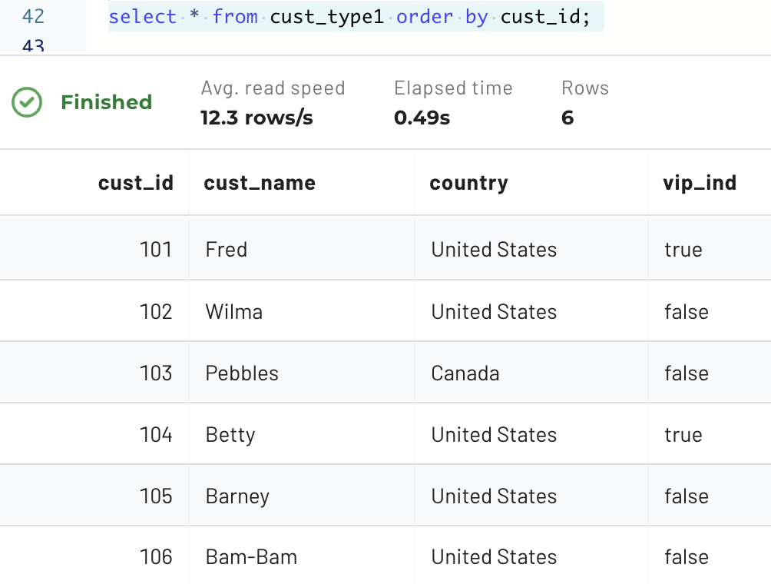

Step 7 - Understanding Slowly Changing Dimensions (SCD)
This approach of overwriting the data when a change is detected is often referred to as a Slowly Changing Dimensions (SCD) Type 1 strategy. SCD Type 2 maintains history by updating the current record to indicate it is not the most current and creating a new record with the current values.

Note: Although there are six types, in practice, Type 1 and Type 2 are the most commonly used.

Run the code below to create a table that includes additional columns. This will allow for a Type 2 solution to be implemented.

CREATE TABLE cust_type2 (
cust_id bigint,
cust_name varchar(50),
country varchar(50),
vip_ind boolean,
active_ind boolean,
active_start_ts timestamp(6),
active_stop_ts timestamp(6)
)
WITH (
type='iceberg'
);

Step 8 - Populate records and mark as active
Populate the same initial three records as before, but this time, mark them active and set the date of this status beginning one month ago.

INSERT INTO cust_type2
(cust_id, cust_name, country, vip_ind,
active_ind, active_start_ts, active_stop_ts)
VALUES
(101, 'Fred', 'United States', false,
true, current_timestamp - INTERVAL '1' month, null),
(102, 'Wilma', 'United States', false,
true, current_timestamp - INTERVAL '1' month, null),
(103, 'Pebbles', 'United States', false,
true, current_timestamp - INTERVAL '1' month, null);

For this use case, you will still use the previously created cust_chg_log table with its simulated new and modified records.

Note: No additional information is needed. These records will become active when the MERGE statement executes.

Step 9 - Understanding MERGE
Review the documentation Supporting MERGE. Notice that only UPDATE and DELETE operations are possible for WHEN MATCHED. All WHEN NOT MATCHED cases only allow for INSERT operations. This approach works for all new records in the change log.

This presents a challenge in cases where a given record already has a change log present in the base table. In such cases, it is necessary to add the updated record, mark it as active, and mark the old record as inactive.

Step 10 - Using the UNION ALL statement
Let’s unpack this process further. To get things ready for MERGE, you have to do a bit of groundwork to ensure that the change logs conform to the specifications above. To do this, you will use a new expression known as UNION ALL, which combines the result set of two or more SELECT statements.

Begin by constructing a Common Table Expression (CTE) using a UNION ALL statement.
The first query to be unioned adds an “is a match” column (set to null) to the cust_chg_log records. It also populates the additional cust_type2 columns with appropriate values. This takes all the rows in the change log and adds the additional columns we need to have to track for type 2.

SELECT null as cust_id_match, cust_id,  cust_name, country, vip_ind,  true as active_ind,  current_timestamp as active_start_ts,  null as active_stop_ts  FROM cust_chg_log | 

The second query to be unioned identifies only records in the base table that need to be updated by those in the change log. This will confirm customers in the change log already exist in the customer table.

SELECT cust_id AS cust_id_match, cust_id,  cust_name, country, vip_ind,  active_ind,  active_start_ts,  active_stop_ts  FROM cust_type2  WHERE cust_id IN (SELECT cust_id FROM cust_chg_log) | 

Now it’s time to pull it all together. Run the full UNION query as listed below. The results should look similar to the image beneath.

SELECT null as cust_id_match, cust_id,
cust_name, country, vip_ind,
true as active_ind,
current_timestamp as active_start_ts,
null as active_stop_ts
FROM cust_chg_log
UNION ALL
SELECT cust_id AS cust_id_match, cust_id,
cust_name, country, vip_ind,
active_ind,
active_start_ts,
active_stop_ts
FROM cust_type2
WHERE cust_id IN (SELECT cust_id FROM cust_chg_log);

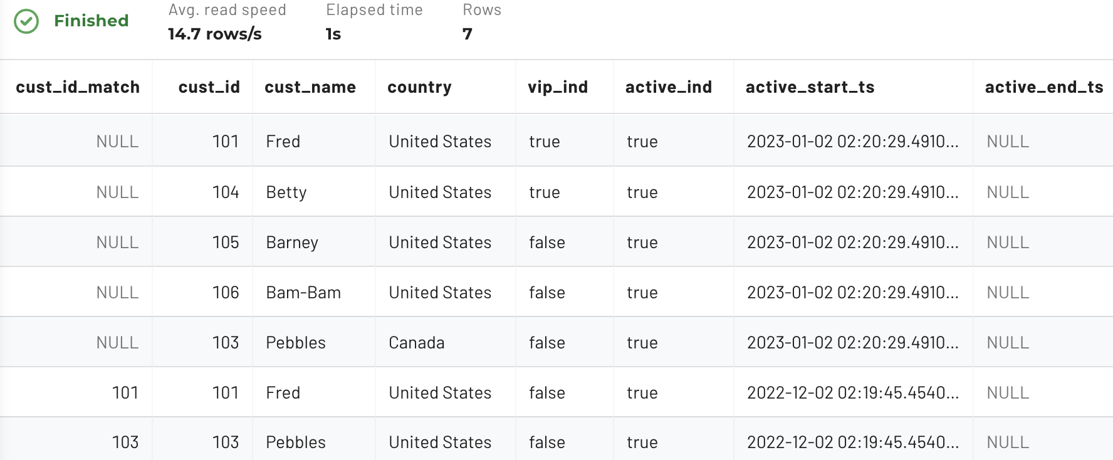

The results show two rows with values in the cust_id_match column. These are the existing Fred and Pebbles records that need to be marked inactive. The results also show 5 rows with null in the match field. These are the 5 rows from cust_chg_log.
- Two of them are the new records for Fred and Pebbles that represent their newly active values.
- The other three are the new records (Barney, Betty, and Bam-Bam) that need to be added to the base table.

Step 11 - Wrap UNION query with existing MERGE query
Wrap the UNION query above with the following SQL above and below your existing query. This allows you to find both records that already exist.

MERGE INTO cust_type2 AS cust  USING (  -- keep your UNION ALL query here  ) AS scd_changes  ON (cust.cust_id = scd_changes.cust_id AND  cust.cust_id = scd_changes.cust_id_match) | 

Step 12 - Mark records as inactive
Now mark these records as inactive.

WHEN MATCHED AND cust.active_ind = true THEN  UPDATE SET active_ind = false,  active_stop_ts = current_timestamp | 

Note: The additional check above takes into consideration that there may be more than one inactive record already existing.

Step 13 - Insert unmatched records and set as active
The unmatched records include both completely new records and new values for existing cust_id records. Insert them as active records using the code below.

WHEN NOT MATCHED THEN  INSERT (cust_id, cust_name, country,  vip_ind, active_ind,  active_start_ts, active_stop_ts)  VALUES (scd_changes.cust_id,  scd_changes.cust_name, scd_changes.country,  scd_changes.vip_ind, scd_changes.active_ind,  scd_changes.active_start_ts,  scd_changes.active_stop_ts) | 

Step 14 - Run full MERGE command
Run the fully assembled MERGE command for this SCD Type 2 implementation.

MERGE INTO cust_type2 AS cust
USING (
SELECT null as cust_id_match, cust_id,
cust_name, country, vip_ind,
true as active_ind,
current_timestamp as active_start_ts,
null as active_stop_ts
FROM cust_chg_log
UNION ALL
SELECT cust_id AS cust_id_match, cust_id,
cust_name, country, vip_ind,
active_ind,
active_start_ts,
active_stop_ts
FROM cust_type2
WHERE cust_id IN (SELECT cust_id FROM cust_chg_log)
) AS scd_changes
ON (cust.cust_id = scd_changes.cust_id AND
cust.cust_id = scd_changes.cust_id_match)
WHEN MATCHED AND cust.active_ind = true THEN
UPDATE SET active_ind = false,
active_stop_ts = current_timestamp
WHEN NOT MATCHED THEN
INSERT (cust_id, cust_name, country,
vip_ind, active_ind,
active_start_ts, active_stop_ts)
VALUES (scd_changes.cust_id,
scd_changes.cust_name, scd_changes.country,
scd_changes.vip_ind, scd_changes.active_ind,
scd_changes.active_start_ts,
scd_changes.active_stop_ts);

Review the output. It should look similar to the image below, reporting seven updated rows.

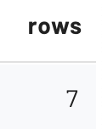

Review the merged results.

SELECT * FROM cust_type2 ORDER BY cust_id, active_start_ts;

The table is correctly populated.
- Fred has been updated to now be a VIP and the original record has been marked inactive.
- Wilma still only shows the original record.
- Pebbles’ country has been updated and the original record is marked inactive.
- The final 3 records are the completely new records from the change log.

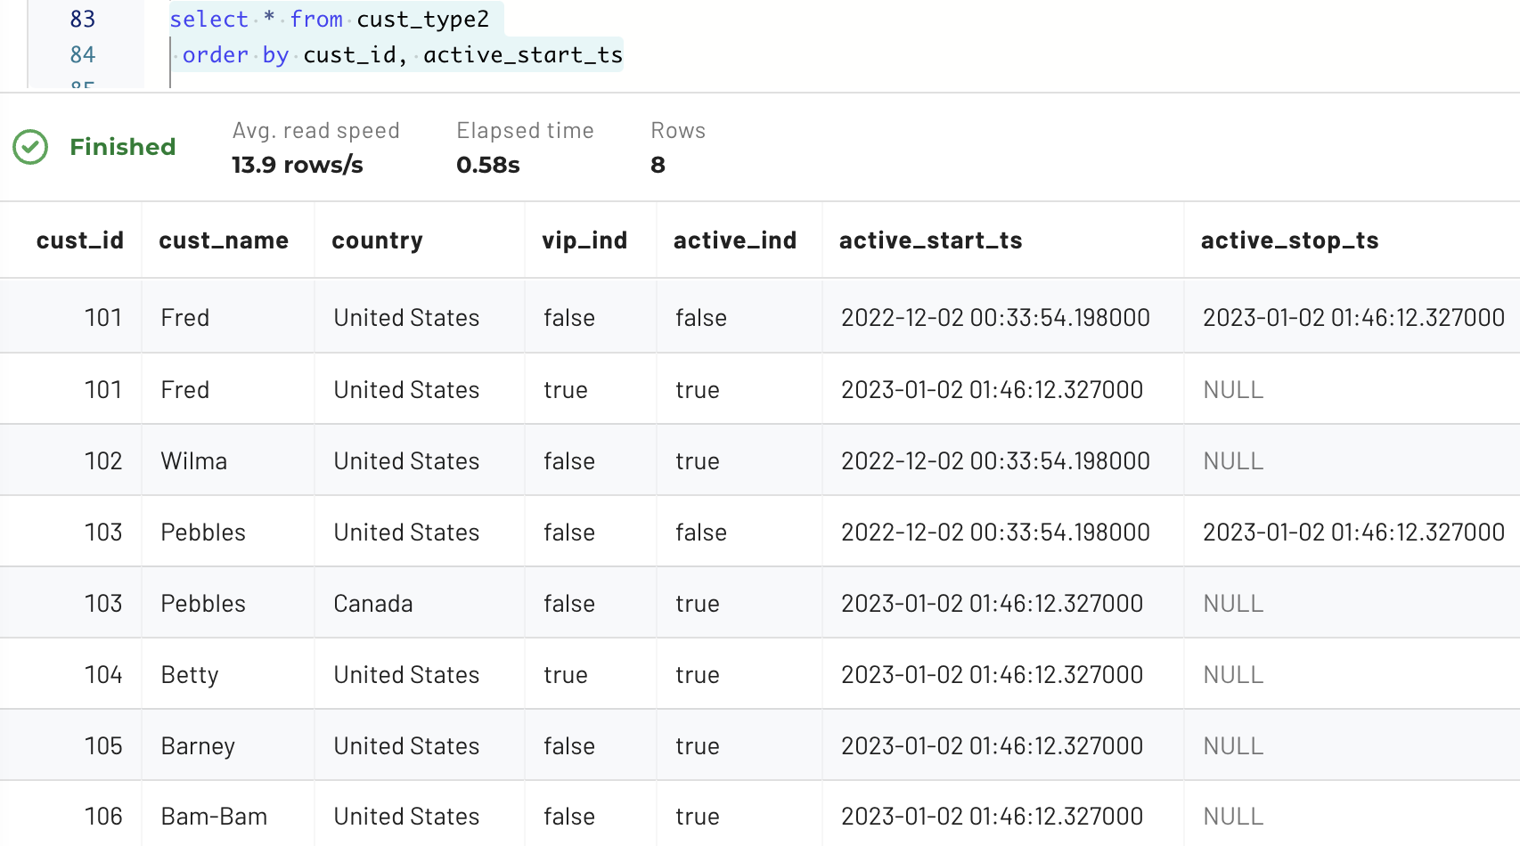

END OF LAB EXERCISE

